# Artificial Intelligence

Notes

* What is good AI
  + Mature AI is
    - Properly built
    - Operationalized
    - Consumed
    - Maintained (to avoid model drift or low volume of training data)
    - Operating at the velocity of the space
  + 3 Pillars
    - AI Readiness
      * Strong Talent
      * Data infrastructure
      * Model infrastructure
    - Ai Enablement
      * Strategic investment
      * Leadership support
      * AI strategy
      * Best practices and governance
      * Fair, unbiased, and ethical AI
      * Trust in AI
    - AI Product
      * Who/What/Where/When/How
      * End2End AI Capability
      * Performance monitoring (KPIs to ensure the model is performant)
      * Maintenance Plan (data refinement for training)
* 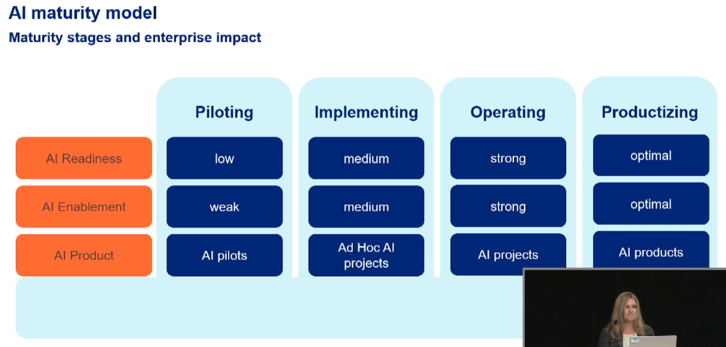
* 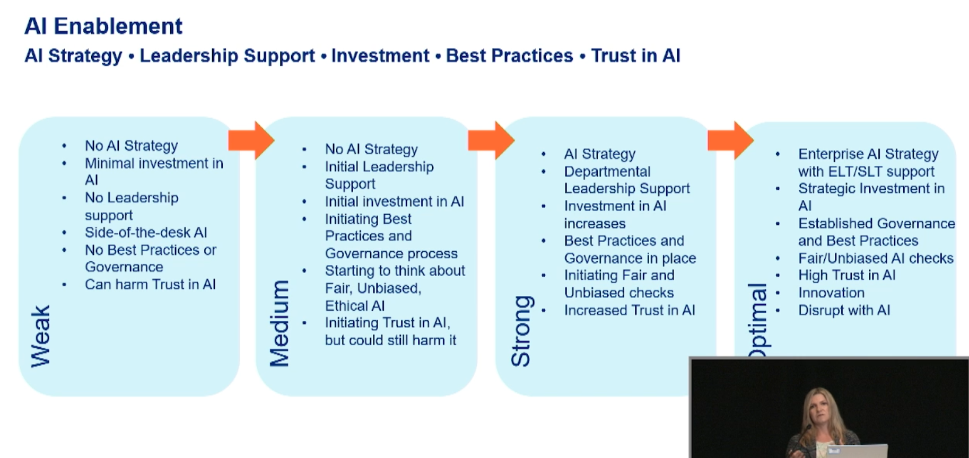
* Aihub.uhg.com